# Online Sample Checking Platform - User Guide and FAQs for NCPES

Contents

Online Sample Checking Platform - User Guide and FAQs for NCPES 1

Login 1

Welcome page 2

Uploading a file 3

Query resolution page 5

Completing query verification 7

Downloading detailed historic comparison tables 8

Uploading a revised file 10

Providing an explanation for a query 10

Submission of the file to Picker 11

Review of uploaded file by Picker 12

Questions 12

Appendix A: Types of CPES Errors, Notices, and Checks 13

Error Queries 13

Check Queries 17

Historic Queries 19

Notice Queries 21

## Login

You can log in to the Online Sample Checker at <https://samplechecker.pickerF.org/>. **Your login details will be sent to you via email from the Picker CPES project team once your sample declaration form has been approved**. Please contact [cpes@pickereurope.ac.uk](mailto:cpes@pickereurope.ac.uk) if you have any questions about this.

## Welcome page

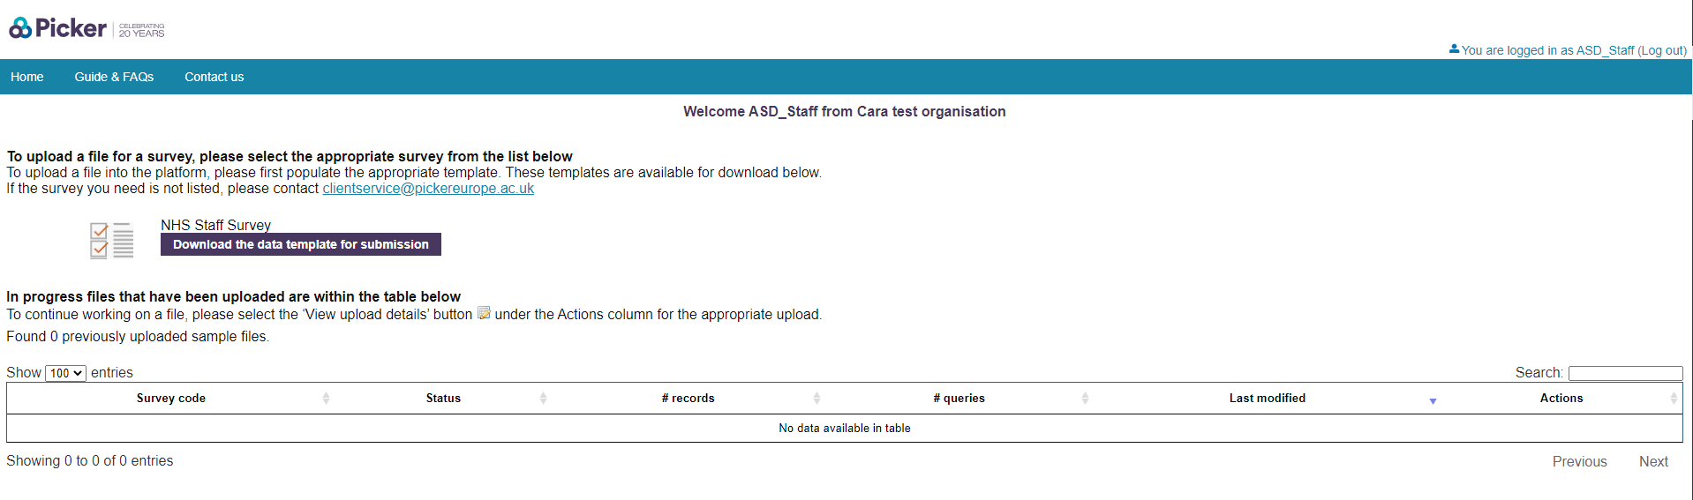

The control menu is the blue bar at the top of the page:

* Home: Returns you to this page.
* Guide & FAQs: Opens an online version of a general guidance document, used across multiple national surveys. Please note that the copy on the survey website (<https://www.ncpes.co.uk/survey-instructions/>) has more detailed instructions on CPES, in particular.
* Contact us: Sends a pre-populated email to [clientservice@pickereurope.ac.uk](mailto:clientservice@pickereurope.ac.uk). **Please note that the CPES project team does not monitor this inbox on a regular basis. Instead, please contact us at** [**cpes@pickereurope.ac.uk**](mailto:cpes@pickereurope.ac.uk) **for a quicker response.**

## Uploading a file

You may see multiple patient surveys on the homepage. Make sure to select the National Cancer Patient Experience Survey.

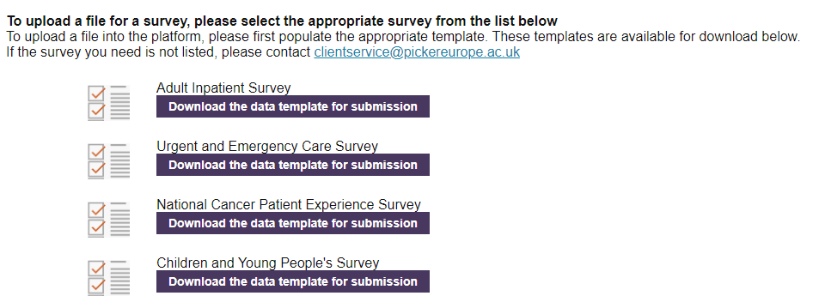

A copy of the **submission template** will have been sent to your organisation already and is also available at: https://www.ncpes.co.uk/survey-instructions/. You can also click **‘Download the data template for submission’** for a copy.

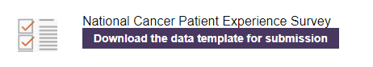

**All files must be uploaded using this template without password protection**: all other formats will be rejected by the platform.

Once your sample is ready for submission and in the **submission template**, it can be uploaded by clicking on the icon or survey name itself:

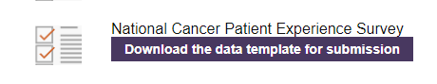

This opens the upload page. Click ‘Choose file’ and select your file. Please also note the advice given on this page:

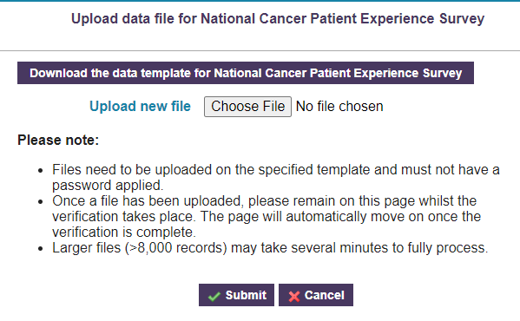

Once a file has been uploaded, the home page will update with information about sample status and progress.

The upload table on the home page will provide a summary of your file’s status:

* **Survey code:** Will be for the survey file you have uploaded e.g. CPES24
* **Status:** Indicates the next step for your file – in the below example, queries from the uploaded file need to be resolved before it can be submitted to Picker
* **# records:** The number of records in the uploaded file
* **# queries:** The number of each type of query *(see Query Summary below)* and how many remain open
* **Last modified:** The date and time the upload was last modified
* **Actions:** Clicking the notebook icon will take you to the Query resolution page

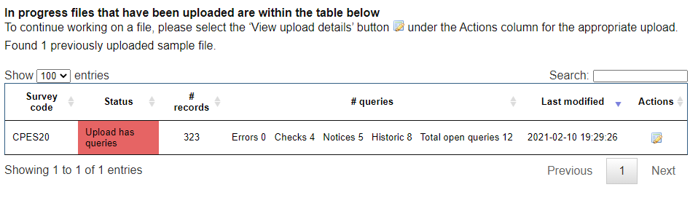

## Query resolution page

Once your file has been uploaded, you will automatically be directed to the query resolution page. You can also access this by clicking the notebook icon under actions in the sample status table on the homepage (see above image).

**Query resolution page:**

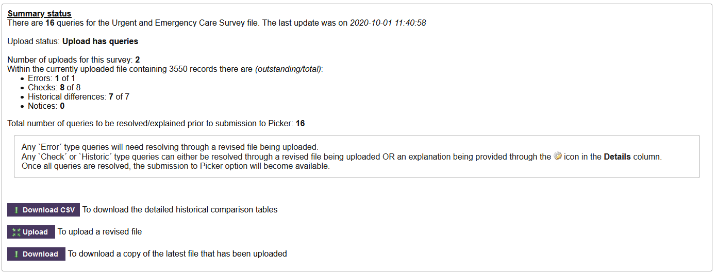

This page provides an overall summary of the status of the file, as well as options to upload a revised file, or download a copy of the most recently uploaded file. It also includes summary information on how to resolve the three query types.

Below this summary information is the table that includes the outcome of the verification run on the uploaded file.

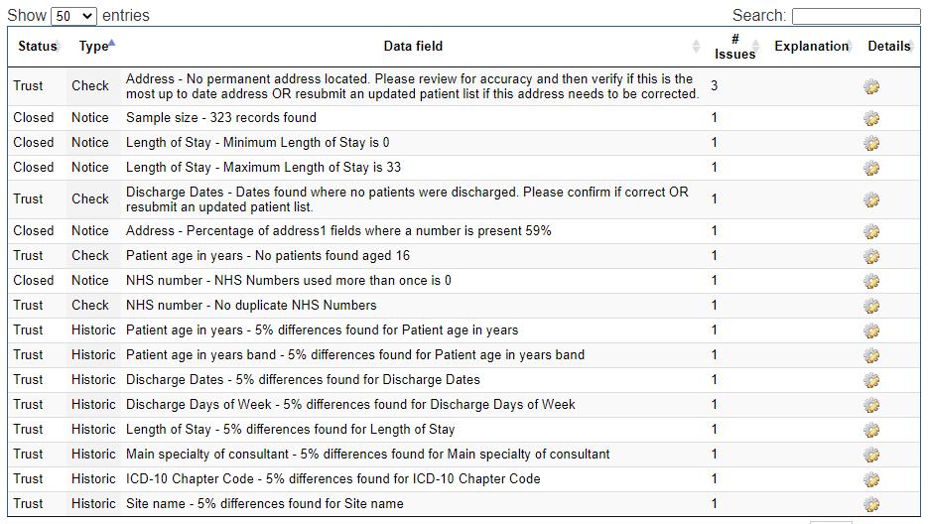

You can use the grey arrows to sort any columns in ascending or descending order.

**Show:** Use this to toggle the number of entries that are displayed on screen

**Search:** Use this to search for a particular query or category e.g. Check, Address

**Status:** This indicates where the query is in the checking process.

* Trust – indicates that your organisation needs to resolve or provide a response to this query
* Closed – indicates that this query is accepted and/or the query is for information purposes only and requires no response
* Picker – indicates that Picker has provided a response

**Type:** There are four types of query the checker will find:

* Error – These need to be corrected through a revised file being uploaded
* Check – These may or may not be an error. Can either be resolved through a revised file being uploaded OR an explanation being provided through the Edit icon in the **Details** column.
* Historic – A comparison with your data from previous years, which may or may not indicate an error. Can either be resolved through a revised file being uploaded OR an explanation being provided through the Edit icon in the **Details** column
* Notice – For your information only and does not need comment

**Data field: A short explanation of the query and how it may be resolved.**

* The platform uses exception reporting and will only display queries where a potential issue has been located. It will not list all possible queries.

**# Issues:** This lists the number of records that the query applies to.

**Explanation:** This is where you can write your response to the query.

**Details:** Click this icon Edit to see more detail about the query – for example, which records or cells are affected by the issue raised.

For more information on the types of errors, notice and checks on NCPES and how to resolve these – please see Appendix A.

## Completing query verification

As noted above, queries can be resolved in two different ways, depending on the query type:

* Error – These need to be corrected through a revised file being uploaded
* Check or Historic – These may or may not be an error. Can either be resolved through a revised file being uploaded OR an explanation being provided through the Edit icon in the **Details** column

In addition to the detail provided in the Data field column, additional details on which values have triggered the query can be found either by:

* Hovering your cursor over the query itself
  + This is most useful when a query affects a small number of records
* Clicking the Edit icon in the **Details** column

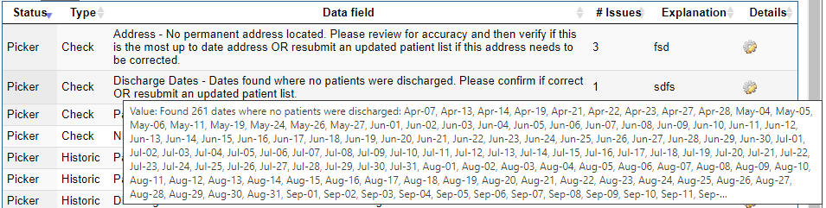

The detailed popup for each query contains both the value(s) that have triggered the query as well as the cell reference for where this value can be located in the most recently uploaded file:

* The first part of the value is the Excel cell reference i.e. O3171 is Column O, Row 3171
* The second part of the value prefixed by ‘RN:’ is the record number for the affected record. This references the last 4 digits of the PRN.

This information is to allow for the quick identification or where query triggers are occurring and their resolution.

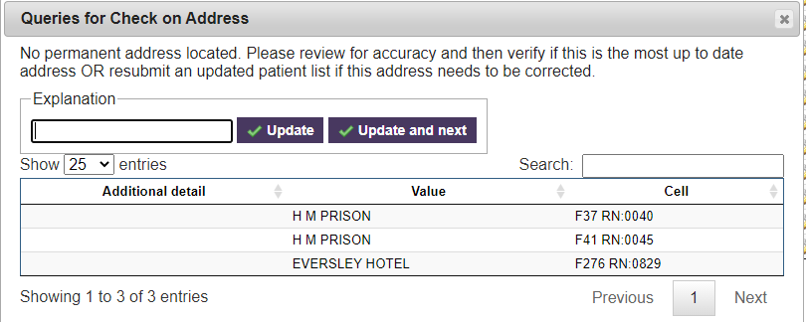

### Downloading detailed historic comparison tables

To support the resolution of any detailed historic queries, a CSV export of the comparison tables can be downloaded. This provides a multi-year comparison of your current file’s data versus previous year’s data and includes a flag where the variation threshold for query has been crossed (5%).

You can access these tables in the following ways:

1) Click on Download CSV. This will download all of the historical comparison tables.

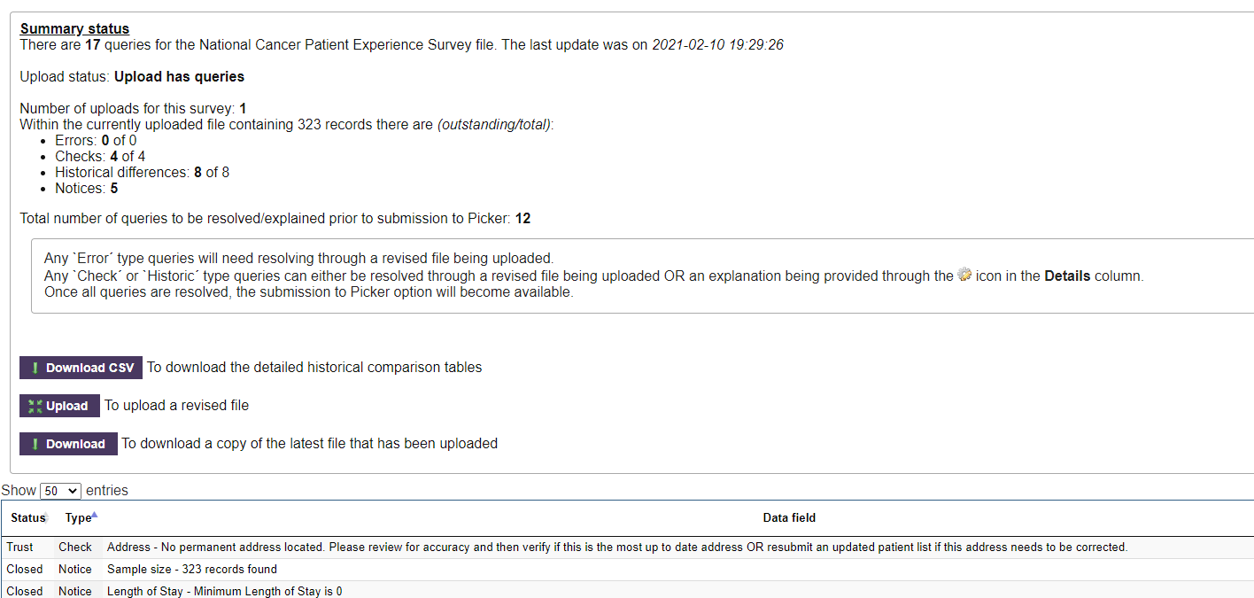

2) Click on the Edit icon next to a Historic query type. You will then be taken to a pop-up box in which you can download the historical comparisons CSV. This will only display the historical comparison tables for whatever query you have clicked on.

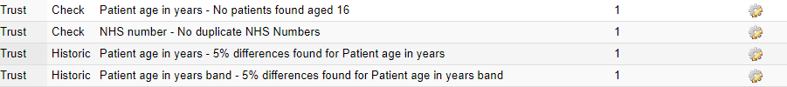

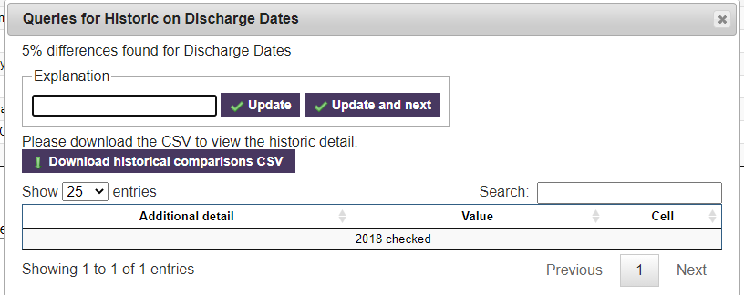

This will open a CSV file in which YES will appear for any differences over the threshold of 5%:

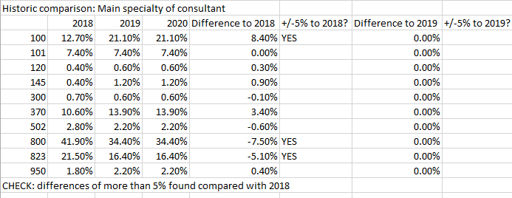

Resolving detailed historic queries:

Explanations for historic differences are required. Depending on the query type, these could take many forms:

* Improvements in the recording of information, such as patient ethnicity
* Changes in the way a PAS records information
* Opening, closing or movement of particular services

However, Picker recognises that obtaining the causal reason behind a historic change is not always possible. As such, where *reasonable effort* has been made to locate the cause behind a change; a confirmation that **the file has been drawn in line with the guidance AND that the data within the provided file reflects the data within the organisation’s system** is an acceptable explanation.

### Uploading a revised file

To upload a revised file select the Upload button and you will be presented with the same upload file screen displayed originally:

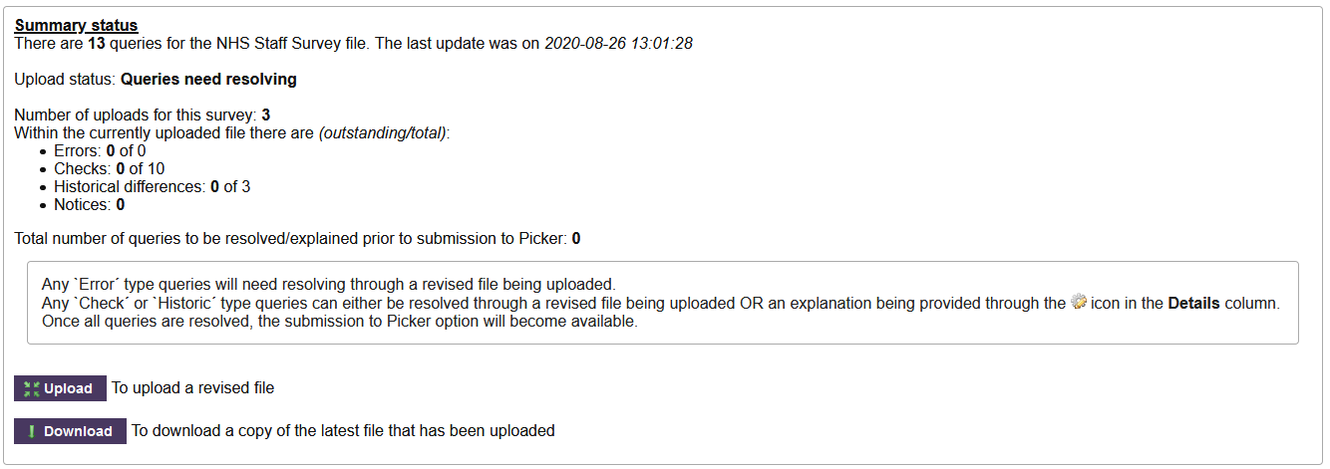

### Providing an explanation for a query

To provide an explanation for a Check or Historic query type, clicking on the Edit icon in the **Details** column will provide a text box for the entry of an explanation. Once an explanation has been entered:

* The **Update** button will save the explanation and close the detailed window for that query
* The **Update and next** will save the explanation and progress to the next query that potentially needs an explanation.

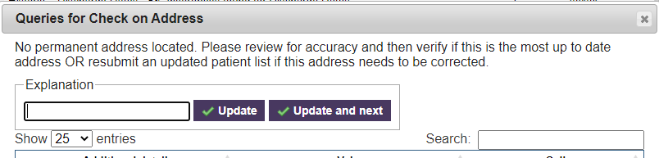

If you have overarching explanations or commentary, this can be entered within the below box.

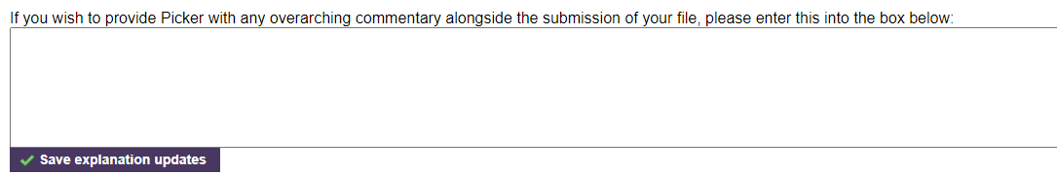

Explanation text that has not been saved will show highlighted in pink on the query resolution page. The explanations can be saved at any time by clicking **Save explanation updates**.

### Submission of the file to Picker

Once there are no remaining errors on the query resolution page and all outstanding Check or Historic query types have a saved explanation, you can submit your file to Picker by clicking **Submit to Picker for acceptance**.

Please note that this button will not appear until Errors have been resolved and explanations have been provided for Checks and Historic queries AND you have clicked **Save explanation updates**.

**To get**  **to appear:**

1) If needed, resubmit your patient file list until any Errors in the table disappear:



2) Provide an explanation around any Check or Historic queries (you do not need to supply this for Notices):

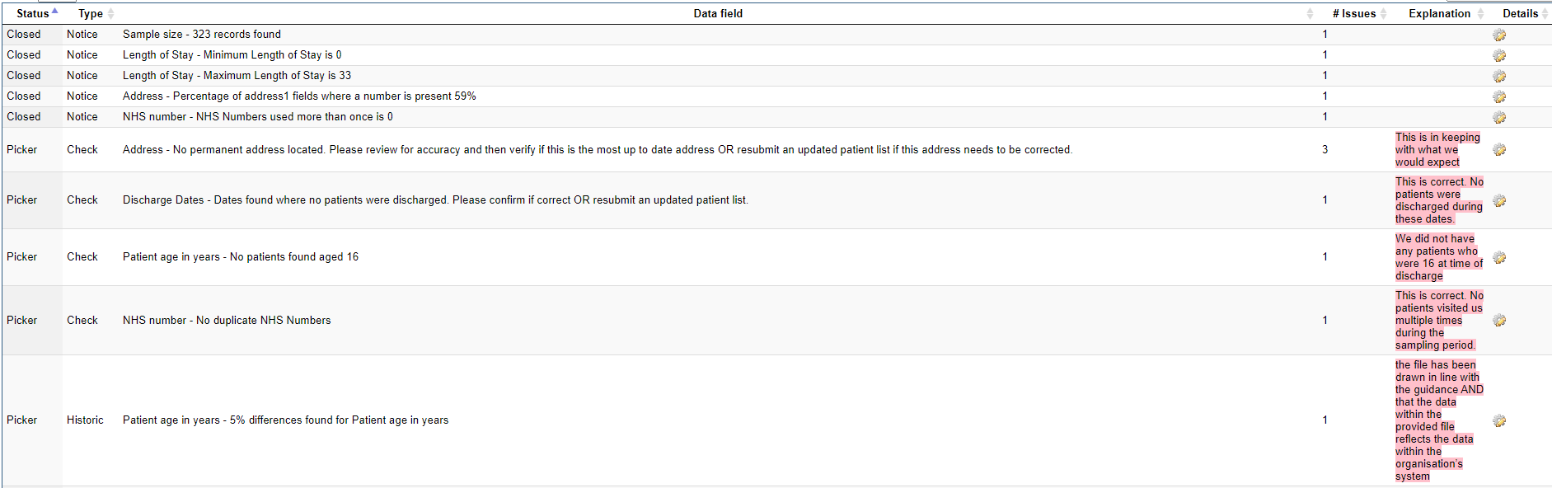

3) Click on **Save explanation updates**:



4) Click on **Submit to Picker for acceptance**:

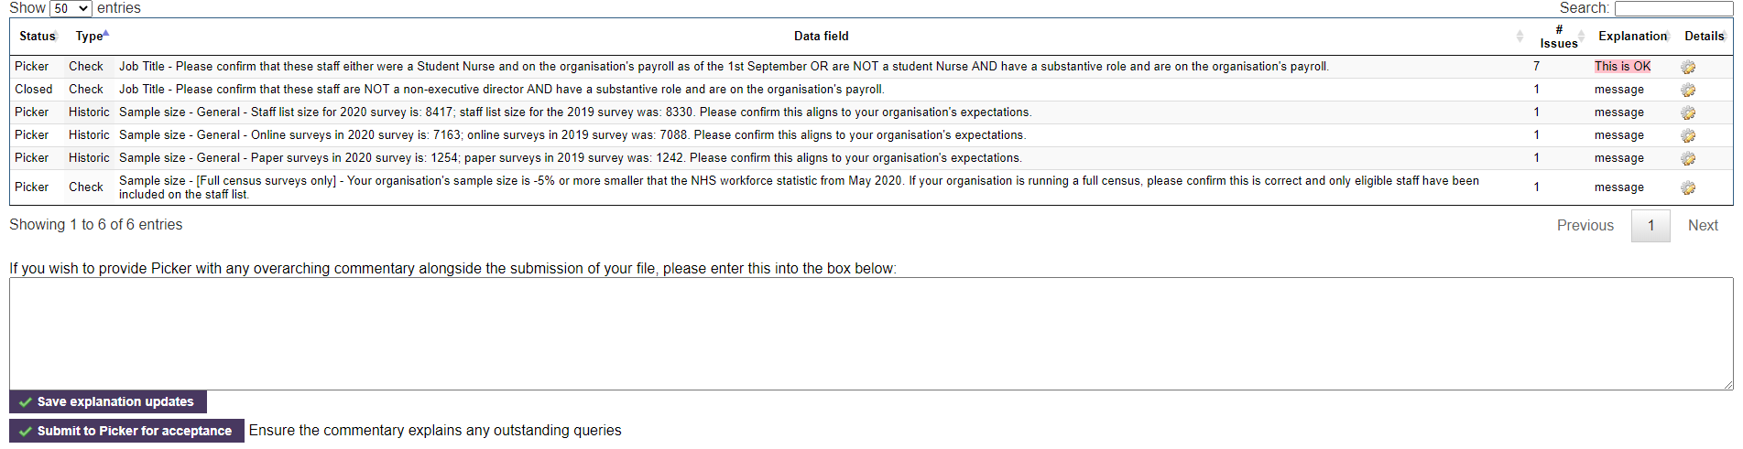

Please note,

* All explanatory text will be reviewed by Picker upon submission
* Once the submission to Picker has been made, no further revisions to the file can be made until either:
  + Picker has reviewed the upload and has followed up on queries
  + Or, a request is made to Picker via [CPES@pickereurope.ac.uk](mailto:CPES@pickereurope.ac.uk)

## Review of uploaded file by Picker

Once an upload has been submitted to Picker, it will be reviewed along with any explanatory notes included as part of the submission.

Depending on the content of the upload or the explanatory notes provided, Picker will either accept your responses, or seek further clarification. We will be in touch via email where additional clarification is required. Either a revised file upload, or updated explanations will be made available on the platform, as appropriate, at that point.

Once all queries have been resolved and the file has been accepted the Welcome page will display an **Accepted by Picker** status.



## Questions

If you have any questions during the sampling process, please contact us at:

[cpes@pickereurope.ac.uk](mailto:cpes@pickereurope.ac.uk)

## Appendix A: Types of CPES Errors, Notices, and Checks

### Error Queries

Please note that the sample checker first searches for any errors with the PRN. If any of these are detected, subsequent checks are halted. Therefore, you may see more errors, notices and historic queries after fixing any PRN errors and uploading an updated patient sample list.

These need to be corrected through a revised file being uploaded. See Uploading a revised file for more information.

|  |  |  |
| --- | --- | --- |
| Query Type | Query Description | Query Meaning |
| Error | Patient record number - Missing/blank value(s) found. This field needs to be populated for each record. | PRN missing. |
| Error | Patient record number - Invalid Survey Code within the PRN value(s) found. The PRN should be in the format: CPES24XXXNNNNN where CPES24 is the survey code, XXX is your trust code [TRUST CODE] and NNNNN is the unique number for each record. | PRN not valid. |
| Error | Trust Code - Missing/blank value(s) found. This field needs to be populated for each record with your organisation's three character code +trustCode+"." | Trust code missing, |
| Error | Trust Code - Invalid value(s) found. This field needs to be populated for each record with your organisation's three character code [TRUST CODE] | Incorrect trust code entered. |
| Error | Missing/blank value(s) found for Day of Discharge. This field needs to be populated for each record. | Day of discharge missing. |
| Error | Missing/blank value(s) found for Month of Discharge. This field needs to be populated for each record. | Month of discharge missing. |
| Error | Missing/blank value(s) found for Year of Discharge. This field needs to be populated for each record. | Year of discharge missing. |
| Error | Discharge date value not correct | Incorrectly formatted date combination. |
| Error | Discharge Dates - Month of Discharge value not in survey period | Discharge dates should be between April – June. The month of discharge is not in this period. |
| Error | Year of Discharge value not the correct year 2024 | Year of discharge not 2024. |
| Error | Postcode - Invalid value(s) found. Supplied postcodes should be in the AB99 8KL, or AB9 8KL format. | Invalid postcode format. |
| Error | Address - Missing/blank value(s) found across all address fields. Paper surveys can only be delivered when addresses are provided. | Too few address lines filled in. |
| Error | Title - Missing/blank value(s) found. This field is optional, but preferable where only first name initials are available to ensure survey is addressed appropriately. | Title missing and Initials/ First Name field is short. |
| Error | Date of birth - Missing/blank value(s) found. This field needs to be populated for each record. | Date of birth missing. |
| Error | Date of birth - Invalid value(s) found. Please resubmit an updated patient list. | Date of birth entered incorrectly (e.g. not a number or incorrect characters like / has been included |
| Error | Gender - Missing/blank value(s) found. This field needs to be populated for each record. Valid values are single digits (either 0, 1, 2 or 9). | Gender missing |
| Error | Gender - Invalid value(s) found. Valid values are single digits (either 0, 1, 2 or 9). | Invalid values entered for gender. |
| Error | Ethnicity - Invalid value(s) found. Valid values are single letters A-H, J-N, P, R, S, Z or a blank cell. | Invalid values entered for ethnicity (not A-H, J-N, P, R, S, Z or a blank cell). |
| Error | Missing/blank value(s) found for Day of Admission. This field needs to be populated for each record. | Day of admission missing. |
| Error | Missing/blank value(s) found for Month of Admission. This field needs to be populated for each record. | Month of admission missing. |
| Error | Missing/blank value(s) found for Year of Admission. This field needs to be populated for each record. column | Year of admission missing. |
| Error | Admission date value not correct | Date of admission not provided in correct format. |
| Error | Date of birth - Invalid value(s) found. Only patients who were aged 16 or older at the time of their discharge are eligible for the survey | Patient is under the age of 16. |
| Error | ICD 10 - Missing/blank value(s) found in ICD-10 Chapter Code. This field needs to be populated for each record. | Triggered if ICD 10 Chapter Code is missing (and ICD 11 hasn’t been provided). |
| Error | ICD 10 Invalid value(s) found. This field has to be populated with a valid ICD-10 Chapter Code for each record. | Invalid value entered in ICD 10 field. |
| Error | ICD 10- Invalid value(s) found. This field should exclude all C44 codes and C84 codes. | Invalid ICD-10 values of C44 and C84 codes entered. |
| Error | ICD 11 - Missing/blank value(s) found in ICD-11 Chapter Code. This field needs to be populated for each record. | Triggered if ICD 11 Chapter Code is missing (and ICD 10 hasn’t been provided). |
| Error | ICD 11 - Invalid value(s) found. This field has to be populated with a valid ICD-11 Chapter Code for each record. | Invalid value entered in ICD 11 field. |
| Error | ICD 11 - Invalid value(s) found. This field should exclude 2C3Z, 2B01, 2B02, 2A90.C, 2A90.A, 2A90.B, 2B0Z and 2B2Z. | Invalid ICD-11 values of 2C3Z, 2B01, 2B02, 2A90.C, 2A90.A, 2A90.B, 2B0Z and/or 2B2Z found. |
| Error | Main specialty - Missing/blank value(s) found. This field needs to be populated for each record. | Main specialty missing. |
| Error | Main specialty - Main specialty value not valid. This should be in the form NNN, as specified by NHS Digital. | Main specialty value does not match NHS Digital |
| Error | Sub ICB Location code - Missing/blank value(s) found. This field needs to be populated for each record. | Sub ICB Location code missing. |
| Error | Sub ICB Location code - Invalid value(s) found. This field needs to be populated using a valid code from NHS Digital's ODS (Organisational Data Service). | Value does not match NHS Digital’s ODS list of Sub ICB Locations. |
| Error | Patient classification - Missing/blank value(s) found. This field needs to be populated for each record. | Patient classification missing. |
| Error | Patient classification - Invalid value(s) found. Valid values are single digits of either 1, 2, 3 or 4. | Must be 1, 2, 3, or 4 |
| Error | Site code - Missing/blank value(s) found in Site Code. This field needs to be populated for each record. | This field is used to populate the name of the hospital on the covering letter sent to the patient. This message is triggered if Site code is missing (and Site name hasn’t been provided). |
| Error | Site code - Invalid value(s) found. This field needs to be populated using a valid code from NHS Digital's ODS (Organisational Data Service). | Invalid site code entered that does not match with NHS Digital’s ODS site code list. |
| Error | Site name - Missing/blank value(s) found. This field needs to be populated for each record. | This field is used to populate the name of the hospital on the covering letter sent to the patient, if site code isn’t provided. This message is triggered is Site name is missing (and Site code hasn’t been provided). |

### Check Queries

Check queries may or may not indicate an error. These can either be resolved through a revised file being uploaded OR an explanation being provided through the Edit icon in the **Details** column. You need to provide an explanation for each check query. Seen Providing an explanation for a query for more information.

|  |  |  |
| --- | --- | --- |
| Query Type | Query Description | Query Meaning |
| Check | NHS Number - Invalid value(s) found. The NHS number should be a 10 digit number | The NHS number contains values other than digits. |
| Check | NHS Number - Invalid value(s) found. The NHS number should be a 10 digit number | The NHS number is not a valid length (10 digits) |
| Check | Address- No permanent address located. Please review for accuracy and then verify if this is the most up to date address OR resubmit an updated patient list if this address needs to be corrected. | The address entered contains an invalid location. |
| Check | Address - No fixed abode (NFA) value(s) found. Paper surveys would potentially not stand a reasonable chance of being delivered. Please confirm if is a valid address OR resubmit an updated patient list without these record(s) present. | No fixed abode values found. |
| Check | Postcode - Missing/blank value(s) found. This field should ideally be populated for each record to ensure a reasonable chance for delivery. Please confirm if correct OR resubmit an updated patient list. | Missing or blank values were found for postcode. Please check if these are available. If not available, please ensure that the record has a reasonable chance of being delivered (e.g. address fields complete enough for mailing to be delivered). |
| Check | Title - Missing/blank value(s) found. | Title is missing. |
| Check | Title - Potentially invalid value(s) found. This field is optional, but preferable where only first name initials are available to ensure survey is addressed appropriately. | Triggered if the first name/initials column is 1 or 2 characters and title is blank. |
| Check | Initials / First name - Missing/blank value(s) found. This field needs to be populated for each record. | Initials or first name missing. |
| Check | Initials / First name - Non-standard character(s) found. Please confirm if correct OR resubmit an updated patient list with the initials/first name updated. | Non-standard characters, such as numbers found in the initials or first name. |
| Check | Surname - Missing/blank value(s) found. This field needs to be populated for each record. | Surname missing. |
| Check | Surname - Non-standard character(s) found. Please confirm if correct OR resubmit an updated patient list with the surname updated. | Non-standard characters, such as numbers found in the surname. |
| Check | Gender - Potential mismatch between gender value(s) and title(s). Please confirm if correct OR resubmit an updated patient list. | Triggered when there is a male title and female gender or female title and male gender. |
| Check | Year of Admission value may not be the correct year 2024 | Admission year not 2024  . |
| Check | Record found with age above 100. Please confirm that the patient is alive and eligible for the survey OR upload a revised patient list. | Patient is 100+ years old. |
| Check | Invalid Length of Stay calculated via admission and discharge dates | Length of stay is less than 0. |
| Check | Record found with a length of stay over 100 days. Please confirm if correct OR resubmit an updated patient list. | Length of stay is over 100 days. |
| Check | Sub ICB Location code. Please confirm if the address is a UK postal address OR resubmit an updated patient list. | Non-English Sub ICB Location code entered. |
| Check | Dates found where no patients were discharged. Please confirm if correct OR resubmit an updated patient list. | Dates found during the sampling period in which no patients were seen. |
| Check | No patients found aged 16 | Patients may be 16 years of age if they were 16 when discharged. Please make sure that you haven’t excluded them if they are, otherwise, eligible. |
| Check | No day day-case patients found (length of stay=0) | No length of stay equal to 0, indicating that a patient would be a day case. |
| Check | Email - Invalid address(s) found. Please confirm if correct OR resubmit an updated patient list. | Invalid email address or no email address has been submitted. |
| Check | Mobile phone number - Missing/blank value(s) found. Please confirm if correct OR resubmit an updated patient list. | Invalid phone number or no phone number has been submitted. |

### Historic Queries

Historic queries point out where there are +/- 5% differences in your data from previous years, which may or may not indicate an error. These can either be resolved through a revised file being uploaded OR an explanation being provided through the Edit icon in the **Details** column.

Explanations for historic differences are required (see Providing an explanation for a query for more information). Depending on the query type, these could take many forms:

* Improvements in the recording of patient ethnicity
* Changes in the way a PAS records information
* Opening, closing or movement of particular services

However, Picker recognises that obtaining the causal reason behind a historic change is not always possible. As such, where *reasonable effort* has been made to locate the cause behind a change; a confirmation that **the file has been drawn in line with the guidance AND that the data within the provided file reflects the data within the organisation’s system** is an acceptable explanation.

|  |  |  |
| --- | --- | --- |
| Query Type | Query Description | Query Meaning |
| Historic | Patient age in years – 5% differences found for Patient age in years | There is a 5% difference between numbers reported in 2024 against those reported in 2023, and / or 2022 |
| Historic | Patient age in years band – 5% differences found for Patient age in years band | There is a 5% difference between numbers reported in 2024 against those reported in 2023, and / or 2022 |
| Historic | Discharge Dates – 5% differences found for Discharge Dates | There is a 5% difference between numbers reported in 2024 against those reported in 2023, and / or 2022 |
| Historic | Discharge Days of Week – 5% differences found for Discharge Days of Week | There is a 5% difference between numbers reported in 2024 against those reported in 2023, and / or 2022 |
| Historic | Admission Dates – 5% differences found for Admission Dates | There is a 5% difference between numbers reported in 2024 against those reported in 2023, and / or 2022 |
| Historic | Gender – 5% differences found for Gender | There is a 5% difference between numbers reported in 2024 against those reported in 2023, and / or 2022 |
| Historic | Ethnicity – 5% differences found for Ethnicity | There is a 5% difference between numbers reported in 2024 against those reported in 2023, and / or 2022 |
| Historic | Length of Stay – 5% differences found for Length of Stay | There is a 5% difference between numbers reported in 2024 against those reported in 2023, and / or 2022 |
| Historic | Main specialty of consultant – 5% differences found for Main specialty of consultant | There is a 5% difference between numbers reported in 2024 against those reported in 2023, and / or 2022 |
| Historic | ICD-10 Chapter Code – 5% differences found for ICD-10 Chapter Code | There is a 5% difference between numbers reported in 2024 against those reported in 2023, and / or 2022 |
| Historic | Sub ICB Location code– 5% differences found for Sub ICB Location code | There is a 5% difference between numbers reported in 2024 against those reported in 2023, and / or 2022 |
| Historic | Patient classification – 5% differences found for Patient classification | There is a 5% difference between numbers reported in 2024 against those reported in 2023, and / or 2022 |
| Historic | Site name – 5% differences found for Site name | There is a 5% difference between numbers reported in 2024 against those reported in 2023, and / or 2022 |

### Notice Queries

Notice queries do not need to be resolved and do not require explanations. However, they may be helpful for you to review to ensure that your sample appears as expected.

|  |  |  |
| --- | --- | --- |
| Query Type | Query Description | Query Meaning |
| Notice | Sample size – [NUMBER] records found | Indicates how many records exist in the sample list. |
| Notice | Minimum Length of Stay is [NUMBER] | Alerts you to the minimum length of stay in the sample. |
| Notice | Maximum Length of Stay is [NUMBER] | Alerts you to how long the maximum length of stay was in the sample. |
| Notice | Address - Percentage of address1 fields where a number is present [PERCENTAGE] | Alerts you to the percentage of address 1 fields that contain a number. We would ordinarily expect a number in the address 1 field but there may be instances where this is not available. |
| Notice | NHS number - NHS Numbers used more than once is [NUMBER] | This the count of NHS numbers repeated in the sample. Duplicates (or multiple records with the same NHS number) are acceptable for the CPES sample and you should record all eligible instances of care. |
| Notice | NHS number - No duplicate NHS Numbers | There are no duplicate NHS numbers in the sample. Duplicates (or multiple records with the same NHS number) are acceptable for the CPES sample and you should record all eligible instances of care. |